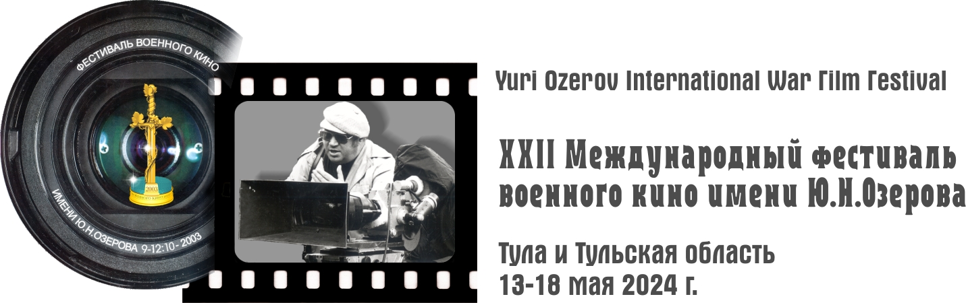

129515, Moscow, Akademika Koroleva str., 8/2, office 114; Tel: 8 (925)-287-0897
www.warcinema.ru; e-mail: onlyart@yandex.ru

APPLICATION FORM

Check the selected category:
 | DOCUMENTARY |  |  | ANIMATED FILM
 | FEATURE FILM |  |  | SHORT FICTION FILM

Catalog details:
Age Restrictions
Title of the film (in Russian in CAPITAL LETTERS):
Title of the film (in English in CAPITAL LETTERS):
(One Line) Studio, Country, Year of Production, Timing:
Producer-
Scriptwriter -
Producer-
Operator-
Composer-
Main actors (for feature films):
Short description: (no more than 60 words, abbreviation is not allowed)
Available film awards:

Producer
Surname, first name, patronymic
Company Name
Address
Telephone | E-mail

Producer
Surname, first name, patronymic
Date of birth
Address
Telephone | E-mail
Experience of participation in festivals/other events (list)
Professional Achievements/Awards

Male Lead Actor (for feature films) |  | Female Lead Actor (for feature films)
Role |  | Role
Surname, first name, patronymic of the actor |  | Surname, first name, patronymic of the actor
LINK TO WORK on YOUTUBE |  | LINK TO WORK on YOUTUBE
Telephone |  | Telephone
E-mail |  | E-mail

Scriptwriter
Surname, first name, patronymic
Telephone | E-mail

Director of photography
Surname, first name, patronymic
Telephone | E-mail

Composer (for feature films)
Surname, first name, patronymic
Telephone | E-mail

The film is provided on a medium | Carrier | Mark Availability
For the Feature Fiction Film category | DCP+DVD
For Other Categories | Download link  HD Quality

ATTACHMENT TO THE APPLICATION

* When sending materials by e-mail, it is necessary to:
Appendix to the application  (material is provided by e-mail * | Mark Availability
Application in electronic form (WORD format without signature and seal, PDF with signature and seal)
Dialogue/Editing Lists (for foreign feature films without subtitles)
Photo of the director/producer (JPEG at least 500 KB or 200 pixels/inch)
Photos (stills) from the film (2-3 pcs, JPEG at least 500 kb or 200 px/inch)
- Attach the above materials in separate files: a photo of the author, 2-3 photos from the film, a download link
- by e-mail: onlyart@yandex.ru, indicating the name of the studio in the subject line of the letter
- IMPORTANTLY!!! If you submit several works from the same studio, only one will be allowed to participate in the competition, if the series,
then only one of the most expressive episodes will be allowed to be shown in the competition (at your discretion).

For short films: The film can be offered for participation and shown at other festivals within the framework of the International Association of Short Films "MOST" on the recommendation of the Organizing Committee of the Y.N. Ozerov International Short Film Association.
I agree with the terms and conditions. I ask you to direct the film "........." to participate in the competition program of the festival, subject to a positive conclusion of the expert commission, or to place it in other programs of the festival (at the discretion of the Organizing Committee). We hereby confirm to the organizing committee of the festival - LLC Firme-Studio "ONLI ART" the transfer of the rights to use the film submitted by us or its fragments free of charge within the framework of the International Military Film Festival named after Y.N. Ozerov (at the discretion of the Organizing Committee):

- on the Internet portals covering the competition, in television and Internet broadcasts of the festival
- for educational purposes and in television programs dedicated to the festival;
- The correctness of the information specified in this application is confirmed by:

Head of the organization/participant ______________________ ____________________________

Signature Deciphering the Signature
« ____ » ____________ 202_

